ML-Classification Assesment-1

* Comparing Values of Manual output vs Coding output:

1]Random forest:

Coding output:

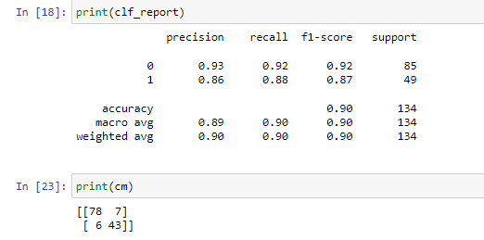

Manual output:

1. Evaluation metrics-Accuracy:

Formula:-

Accuracy=T(0)+T(1)/T(0)+T(1)+F(0)+F(1)

=78+43/78+6+7+43=121/134

Accuracy =0.90

1. Evaluation metrics-Recall

Formula:-

Recall=T(0)/T(0)+F(0)

=78/85=0.92

Recall=T(1)/T(1)+F(1)

=43/49=0.88

1. Evaluation metrics-Precision

Formula:-

Precision=T(0)/T(0)+F(1)

=78/84=0.93

Precision=T(1)/T(1)+F(0)

=43/50=0.86

1. Evaluation metrics-F1 measure

Formula:-

F1 measure=2*Recall*Precision/Recall+Precision

=2*0.92*0.93/0.93+0.92

=0.92

F1 measure=2*Recall*Precision/Recall+Precision

=2*0.88*0.86/0.88+0.86

=0.87

1. Evaluation metrics-Macro Avg

Formula:-

|  |  |  |
| --- | --- | --- |
| Precision | Recall | F1 measure |
| Precision(1)+ Precision(0)/2 | Recall (1)+ Recall (0)/2 | F1 measure (1)+ F1 measure (0)/2 |
| 0.93+0.86/2 | 0.92+0.88/2 | 0.92+0.87/2 |
| 0.89 | 0.90 | 0.90 |

1. Evaluation metrics-Weighted Avg

|  |  |  |
| --- | --- | --- |
| Precision | Recall | F1 measure |
| Precision(1)*85/134+Precision(0)*49/134 | Recall (1)*85/134+ Recall (0)*49/134 | F1 measure (1)*85/134+ F1 measure (0)*49/134 |
| 0.90 | 0.90 | 0.90 |

2]Decision Tree:-

Coding output:

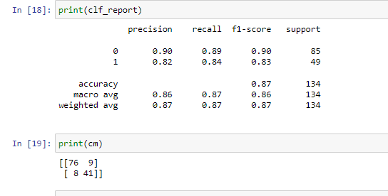

Manual output:

A.Evaluation metrics-Accuracy

Formula:-

Accuracy=T(0)+T(1)/T(0)+T(1)+F(0)+F(1)

=76+41/76+8+9+41=117/134

Accuracy =0.87

1. Evaluation metrics-Recall

Formula:-

Recall=T(0)/T(0)+F(0)

=76/85=0.89

Recall=T(1)/T(1)+F(1)

=41/49=0.84

1. Evaluation metrics-Precision

Formula:-

Precision=T(0)/T(0)+F(1)

=76/84=0.90

Precision=T(1)/T(1)+F(0)

=41/50=0.82

1. Evaluation metrics-F1 measure

Formula:-

F1 measure=2*Recall(0)*Precision(0)/Recall(0)+Precision(0)

=2*0.89*0.90/0.89+0.90

=0.90

F1 measure=2*Recall(1)*Precision(1)/Recall(1)+Precision(1)

=2*0.84*0.82/0.84+0.82

=0.83

1. Evaluation metrics-Macro Avg

Formula:-

|  |  |  |
| --- | --- | --- |
| Precision | Recall | F1 measure |
| Precision(1)+ Precision(0)/2 | Recall (1)+ Recall (0)/2 | F1 measure (1)+ F1 measure (0)/2 |
| 0.90+0.82/2 | 0.89+0.84/2 | 0.90+0.83/2 |
| 0.86 | 0.87 | 0.86 |

1. Evaluation metrics-Weighted Avg

|  |  |  |
| --- | --- | --- |
| Precision | Recall | F1 measure |
| Precision(1)*85/134+Precision(0)*49/134 | Recall (1)*85/134+ Recall (0)*49/134 | F1 measure (1)*85/134+ F1 measure (0)*49/134 |
| 0.87 | 0.87 | 0.87 |

3]SVM:-

Coding output:

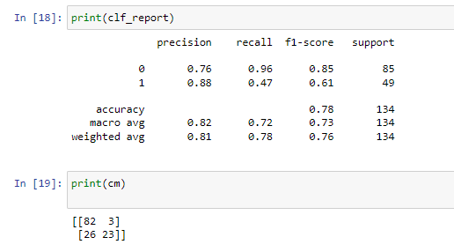

Manual output:

A.Evaluation metrics-Accuracy:

Formula:-

Accuracy=T(0)+T(1)/T(0)+T(1)+F(0)+F(1)

=82+23/82+3+26+23

Accuracy =0.78

1. Evaluation metrics-Recall

Formula:-

Recall=T(0)/T(0)+F(0)

=82/85=0.96

Recall=T(1)/T(1)+F(1)

=23/49=0.47

1. Evaluation metrics-Precision

Formula:-

Precision=T(0)/T(0)+F(1)

=82/108=0.76

Precision=T(1)/T(1)+F(0)

=23/26=0.88

1. Evaluation metrics-F1 measure

Formula:-

F1 measure=2*Recall(0)*Precision(0)/Recall(0)+Precision(0)

=2*0.96*0.76/0.96+0.76

=0.85

F1 measure=2*Recall(1)*Precision(1)/Recall(1)+Precision(1)

=2*0.47*0.88/0.47+0.88

=0.61

1. Evaluation metrics-Macro Avg

Formula:-

|  |  |  |
| --- | --- | --- |
| Precision | Recall | F1 measure |
| Precision(1)+ Precision(0)/2 | Recall (1)+ Recall (0)/2 | F1 measure (1)+ F1 measure (0)/2 |
| 0.76+0.88/2 | 0.96+0.47/2 | 0.85+0.61/2 |
| 0.82 | 0.72 | 0.73 |

1. Evaluation metrics-Weighted Avg

|  |  |  |
| --- | --- | --- |
| Precision | Recall | F1 measure |
| Precision(1)*85/134+Precision(0)*49/134 | Recall (1)*85/134+ Recall (0)*49/134 | F1 measure (1)*85/134+ F1 measure (0)*49/134 |
| 0.81 | 0.78 | 0.76 |

4)LOGISTIC REGRESSION:-

Coding output:

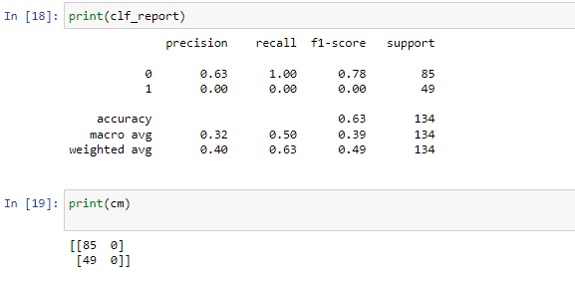

Manual output:

A.Evaluation metrics-Accuracy:

Formula:-

A. Accuracy=T(0)+T(1)/T(0)+T(1)+F(0)+F(1)

=85+0/85+0+49+0

Accuracy =0.63

1. Evaluation metrics-Recall

Formula:-

Recall(0)=T(0)/T(0)+F(0)

=85/49=1.00

Recall(1)=T(1)/T(1)+F(1)

=0/49=0.00

1. Evaluation metrics-Precision

Formula:-

Precision(0)=T(0)/T(0)+F(1)

=85/134=0.63

Precision(1)=T(1)/T(1)+F(0)

=85/0=0.00

1. Evaluation metrics-F1 measure

Formula:-

F1 measure=2*Recall(0)*Precision(0)/Recall(0)+Precision(0)

=2*1.00*0.63/1.00+0.63

=0.78

F1 measure=2*Recall(1)*Precision(1)/Recall(1)+Precision(1)

=2*0.00*0.00/0.00+0.00

=0.00

1. Evaluation metrics-Macro Avg

Formula:-

|  |  |  |
| --- | --- | --- |
| Precision | Recall | F1 measure |
| Precision(1)+ Precision(0)/2 | Recall (1)+ Recall (0)/2 | F1 measure (1)+ F1 measure (0)/2 |
| 0.63+0.00/2 | 0.00+1.00/2 | 0.78+0.00/2 |
| 0.32 | 0.50 | 0.39 |

1. Evaluation metrics-Weighted Avg

|  |  |  |
| --- | --- | --- |
| Precision | Recall | F1 measure |
| Precision(1)*85/134+Precision(0)*49/134 | Recall (1)*85/134+ Recall (0)*49/134 | F1 measure (1)*85/134+ F1 measure (0)*49/134 |
| 0.40 | 0.63 | 0.49 |

5)KNN:-

Coding output:

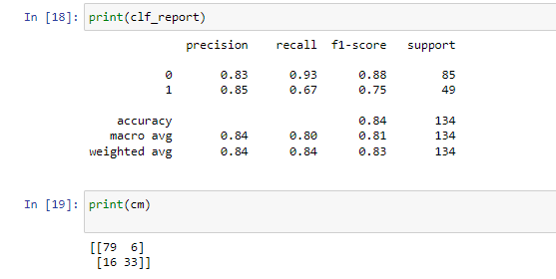

Manual output:

A.Evaluation metrics-Accuracy:

Formula:-

Accuracy=T(0)+T(1)/T(0)+T(1)+F(0)+F(1)

=79+33/79+6+16+33

Accuracy =0.84

B.Evaluation metrics-Recall

Formula:-

Recall(0)=T(0)/T(0)+F(0)

=79/79+6=0.93

Recall(1)=T(1)/T(1)+F(1)

=33/33+16=0.67

C.Evaluation metrics-Precision

Formula:-

Precision(0)=T(0)/T(0)+F(1)

=79/95=0.83

Precision(1)=T(1)/T(1)+F(0)

=33/33+6=0.85

E.Evaluation metrics-F1 measure

Formula:-

F1 measure=2*Recall(0)*Precision(0)/Recall(0)+Precision(0)

=2*0.93*0.83/0.93+0.83

=0.88

F1 measure=2*Recall(1)*Precision(1)/Recall(1)+Precision(1)

=2*0.67*0.85/0.67+0.85

=0.75

F.Evaluation metrics-Macro Avg

Formula:-

|  |  |  |
| --- | --- | --- |
| Precision | Recall | F1 measure |
| Precision(1)+ Precision(0)/2 | Recall (1)+ Recall (0)/2 | F1 measure (1)+ F1 measure (0)/2 |
| 0.85+0.83/2 | 0.93+0.67/2 | 0.88+0.75/2 |
| 0.84 | 0.80 | 0.81 |

1. Evaluation metrics-Weighted Avg

|  |  |  |
| --- | --- | --- |
| Precision | Recall | F1 measure |
| Precision(1)*85/134+Precision(0)*49/134 | Recall (1)*85/134+ Recall (0)*49/134 | F1 measure (1)*85/134+ F1 measure (0)*49/134 |
| 0.84 | 0.84 | 0.83 |

6) NAVIES’BAYES:-

* Multinomial Coding output:

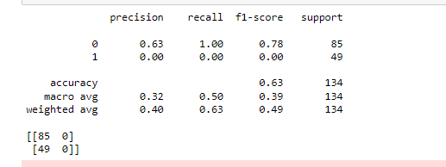

Manual output:

A.Evaluation metrics-Accuracy:

Formula:-

Accuracy=T(0)+T(1)/T(0)+T(1)+F(0)+F(1)

=85+0/85+0+49+0

Accuracy =0.63

B.Evaluation metrics-Recall

Formula:-

Recall(0)=T(0)/T(0)+F(0)

=85/49=1.00

Recall(1)=T(1)/T(1)+F(1)

=0/49=0.00

1. Evaluation metrics-Precision

Formula:-

Precision(0)=T(0)/T(0)+F(1)

=85/134=0.63

Precision(1)=T(1)/T(1)+F(0)

=85/0=0.00

1. Evaluation metrics-F1 measure

Formula:-

F1 measure=2*Recall(0)*Precision(0)/Recall(0)+Precision(0)

=2*1.00*0.63/1.00+0.63

=0.78

F1 measure=2*Recall(1)*Precision(1)/Recall(1)+Precision(1)

=2*0.00*0.00/0.00+0.00

=0.00

1. Evaluation metrics-Macro Avg

Formula:-

|  |  |  |
| --- | --- | --- |
| Precision | Recall | F1 measure |
| Precision(1)+ Precision(0)/2 | Recall (1)+ Recall (0)/2 | F1 measure (1)+ F1 measure (0)/2 |
| 0.63+0.00/2 | 0.00+1.00/2 | 0.78+0.00/2 |
| 0.32 | 0.50 | 0.39 |

1. Evaluation metrics-Weighted Avg

|  |  |  |
| --- | --- | --- |
| Precision | Recall | F1 measure |
| Precision(1)*85/134+Precision(0)*49/134 | Recall (1)*85/134+ Recall (0)*49/134 | F1 measure (1)*85/134+ F1 measure (0)*49/134 |
| 0.40 | 0.63 | 0.49 |

* BERNOULIS METHOD:-

Coding output:



Manual output:

A.Evaluation metrics-Accuracy:

Formula:-

Accuracy=T(0)+T(1)/T(0)+T(1)+F(0)+F(1)

=85+0/85+0+49+0

Accuracy =0.63

B.Evaluation metrics-Recall

Formula:-

Recall(0)=T(0)/T(0)+F(0)

=85/49=1.00

Recall(1)=T(1)/T(1)+F(1)

=0/49=0.00

C.Evaluation metrics-Precision

Formula:-

Precision(0)=T(0)/T(0)+F(1)

=85/134=0.63

Precision(1)=T(1)/T(1)+F(0)

=85/0=0.00

1. Evaluation metrics-F1 measure

Formula:-

F1 measure=2*Recall(0)*Precision(0)/Recall(0)+Precision(0)

=2*1.00*0.63/1.00+0.63

=0.78

F1 measure=2*Recall(1)*Precision(1)/Recall(1)+Precision(1)

=2*0.00*0.00/0.00+0.00

=0.00

1. Evaluation metrics-Macro Avg

Formula:-

|  |  |  |
| --- | --- | --- |
| Precision | Recall | F1 measure |
| Precision(1)+ Precision(0)/2 | Recall (1)+ Recall (0)/2 | F1 measure (1)+ F1 measure (0)/2 |
| 0.63+0.00/2 | 0.00+1.00/2 | 0.78+0.00/2 |
| 0.32 | 0.50 | 0.39 |

1. Evaluation metrics-Weighted Avg

|  |  |  |
| --- | --- | --- |
| Precision | Recall | F1 measure |
| Precision(1)*85/134+Precision(0)*49/134 | Recall (1)*85/134+ Recall (0)*49/134 | F1 measure (1)*85/134+ F1 measure (0)*49/134 |
| 0.40 | 0.63 | 0.49 |

* Categorical NB:-

Coding output-

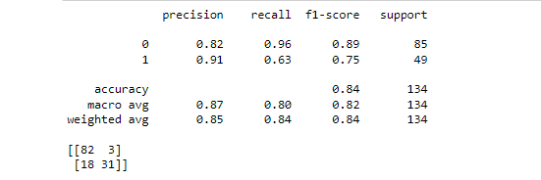

Manual output:

A.Evaluation metrics-Accuracy:

Formula:-

Accuracy=T(0)+T(1)/T(0)+T(1)+F(0)+F(1)

=82+0/82+3+18+31

Accuracy =0.84

B.Evaluation metrics-Recall

Formula:-

Recall(0)=T(0)/T(0)+F(0)

=82/82+3=0.96

Recall(1)=T(1)/T(1)+F(1)

=31/18+31=0.63

C.Evaluation metrics-Precision

Formula:-

Precision(0)=T(0)/T(0)+F(1)

=82/100=0.82

Precision(1)=T(1)/T(1)+F(0)

=3149=0.91

D.Evaluation metrics-F1 measure

Formula:-

F1 measure=2*Recall(0)*Precision(0)/Recall(0)+Precision(0)

=2*0.96*0.82/0.96+0.82

=0.89

F1 measure=2*Recall(1)*Precision(1)/Recall(1)+Precision(1)

=2*0.63*0.91/0.63+0.91

=0.75

E.Evaluation metrics-Macro Avg

Formula:-

|  |  |  |
| --- | --- | --- |
| Precision | Recall | F1 measure |
| Precision(1)+ Precision(0)/2 | Recall (1)+ Recall (0)/2 | F1 measure (1)+ F1 measure (0)/2 |
| 0.91+0.82/2 | 0.63+0.96/2 | 0.89+0.75/2 |
| 0.87 | 0.80 | 0.82 |

F.Evaluation metrics-Weighted Avg

|  |  |  |
| --- | --- | --- |
| Precision | Recall | F1 measure |
| Precision(1)*85/134+Precision(0)*49/134 | Recall (1)*85/134+ Recall (0)*49/134 | F1 measure (1)*85/134+ F1 measure (0)*49/134 |
| 0.85 | 0.84 | 0.84 |

* ComplementNB:-

Coding output:

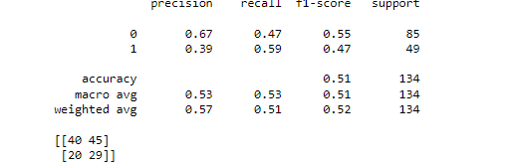

Manual output:

A.Evaluation metrics-Accuracy:

Formula:-

Accuracy=T(0)+T(1)/T(0)+T(1)+F(0)+F(1)

=40+29/40+29+45+20

Accuracy =0.51

B.Evaluation metrics-Recall

Formula:-

Recall(0)=T(0)/T(0)+F(0)

=40/40+45=0.47

Recall(1)=T(1)/T(1)+F(1)

=29/29+20=0.59

C.Evaluation metrics-Precision

Formula:-

Precision(0)=T(0)/T(0)+F(1)

=40/60=0.67

Precision(1)=T(1)/T(1)+F(0)

=29/29+45=0.39

D.Evaluation metrics-F1 measure

Formula:-

F1 measure=2*Recall(0)*Precision(0)/Recall(0)+Precision(0)

=2*0.47*0.67/0.47+0.67

=0.55

F1 measure=2*Recall(1)*Precision(1)/Recall(1)+Precision(1)

=2*0.59*0.39/0.59+0.39

=0.47

E.Evaluation metrics-Macro Avg

Formula:-

|  |  |  |
| --- | --- | --- |
| Precision | Recall | F1 measure |
| Precision(1)+ Precision(0)/2 | Recall (1)+ Recall (0)/2 | F1 measure (1)+ F1 measure (0)/2 |
| 0.67+0.39/2 | 0.47+0.59/2 | 0.55+0.47/2 |
| 0.53 | 0.53 | 0.51 |

F.Evaluation metrics-Weighted Avg

|  |  |  |
| --- | --- | --- |
| Precision | Recall | F1 measure |
| Precision(1)*85/134+Precision(0)*49/134 | Recall (1)*85/134+ Recall (0)*49/134 | F1 measure (1)*85/134+ F1 measure (0)*49/134 |
| 0.57 | 0.51 | 0.52 |